ASSIGNMENT – 10
Q1. Representation of Undirected Graph in the form of Adjacency Matrix.
#include <stdio.h>
#include<stdlib.h>

int main() {
int n, e, u, v;
printf("Enter number of Vertices: ");
scanf("%d", &n);
printf("Enter number of Edges: ");
scanf("%d", &e);

int adjMat[n][n];

for(int i = 0; i < n; i++)
for(int j = 0; j < n; j++)
adjMat[i][j] = 0;

printf("Enter edges (u v):\n");
for(int i = 0; i < e; i++) {
scanf("%d %d", &u, &v);
adjMat[u][v] = 1;
adjMat[v][u] = 1;
}

printf("\nAdjacency Matrix Representation:\n");
for(int i = 0; i < n; i++) {
for(int j = 0; j < n; j++)
printf("%d ", adjMat[i][j]);
printf("\n");
}

return 0;
}
Output:
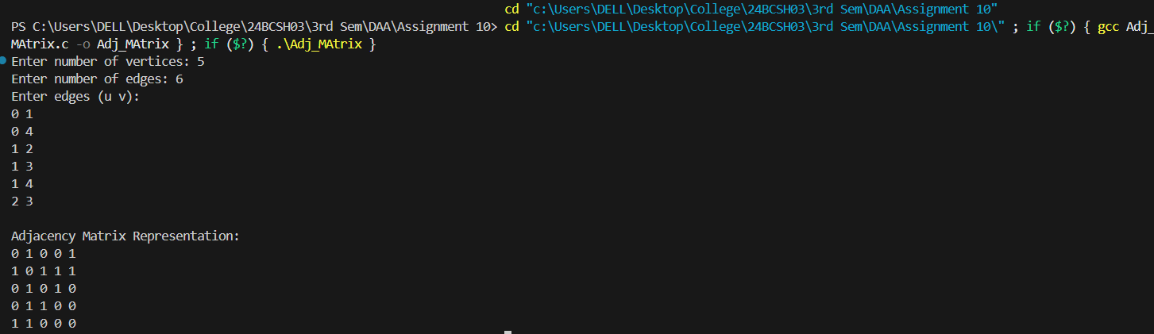

Q2. Representation of Undirected Graph in the form of Adjacency List.

#include <stdio.h>
#include <stdlib.h>

typedef struct Node {
int data;
struct Node* next;
} Node;

Node* createNode(int v) {
Node* newNode = (Node*)malloc(sizeof(Node));
newNode->data = v;
newNode->next = NULL;
return newNode;
}

int main() {
int n, e;
printf("Enter number of Vertices: ");
scanf("%d", &n);
printf("Enter number of Edges: ");
scanf("%d", &e);

Node* adjList[n];
for(int i=0; i<n; i++) {
adjList[i] = NULL;
}
printf("Enter edges (u v):\n");
for(int i=0; i<e; i++) {
int u, v;
scanf("%d %d", &u, &v);

Node* newNode = createNode(v);
newNode->next = adjList[u];
adjList[u] = newNode;

newNode = createNode(u);
newNode->next = adjList[v];
adjList[v] = newNode;
}

printf("\nAdjacency List Representation:\n");
for(int i=0; i<n; i++) {
printf("%d: ", i);
Node* temp = adjList[i];
while(temp) {
printf("%d -> ", temp->data);
temp = temp->next;
}
printf("NULL\n");
}
return 0;
}
Output:
